**AWS CLOUD COMPUTING**

**Practical no.3**

**AIM:** *Create S3 Bucket , EBS and EFS describe in detail .*

## **Step 1. Select a region**

One of the most important steps is to select the desired AWS region. This can be done from the top navigation bar of the AWS Console.

## **Step 2.** Navigate to the S3 Console.

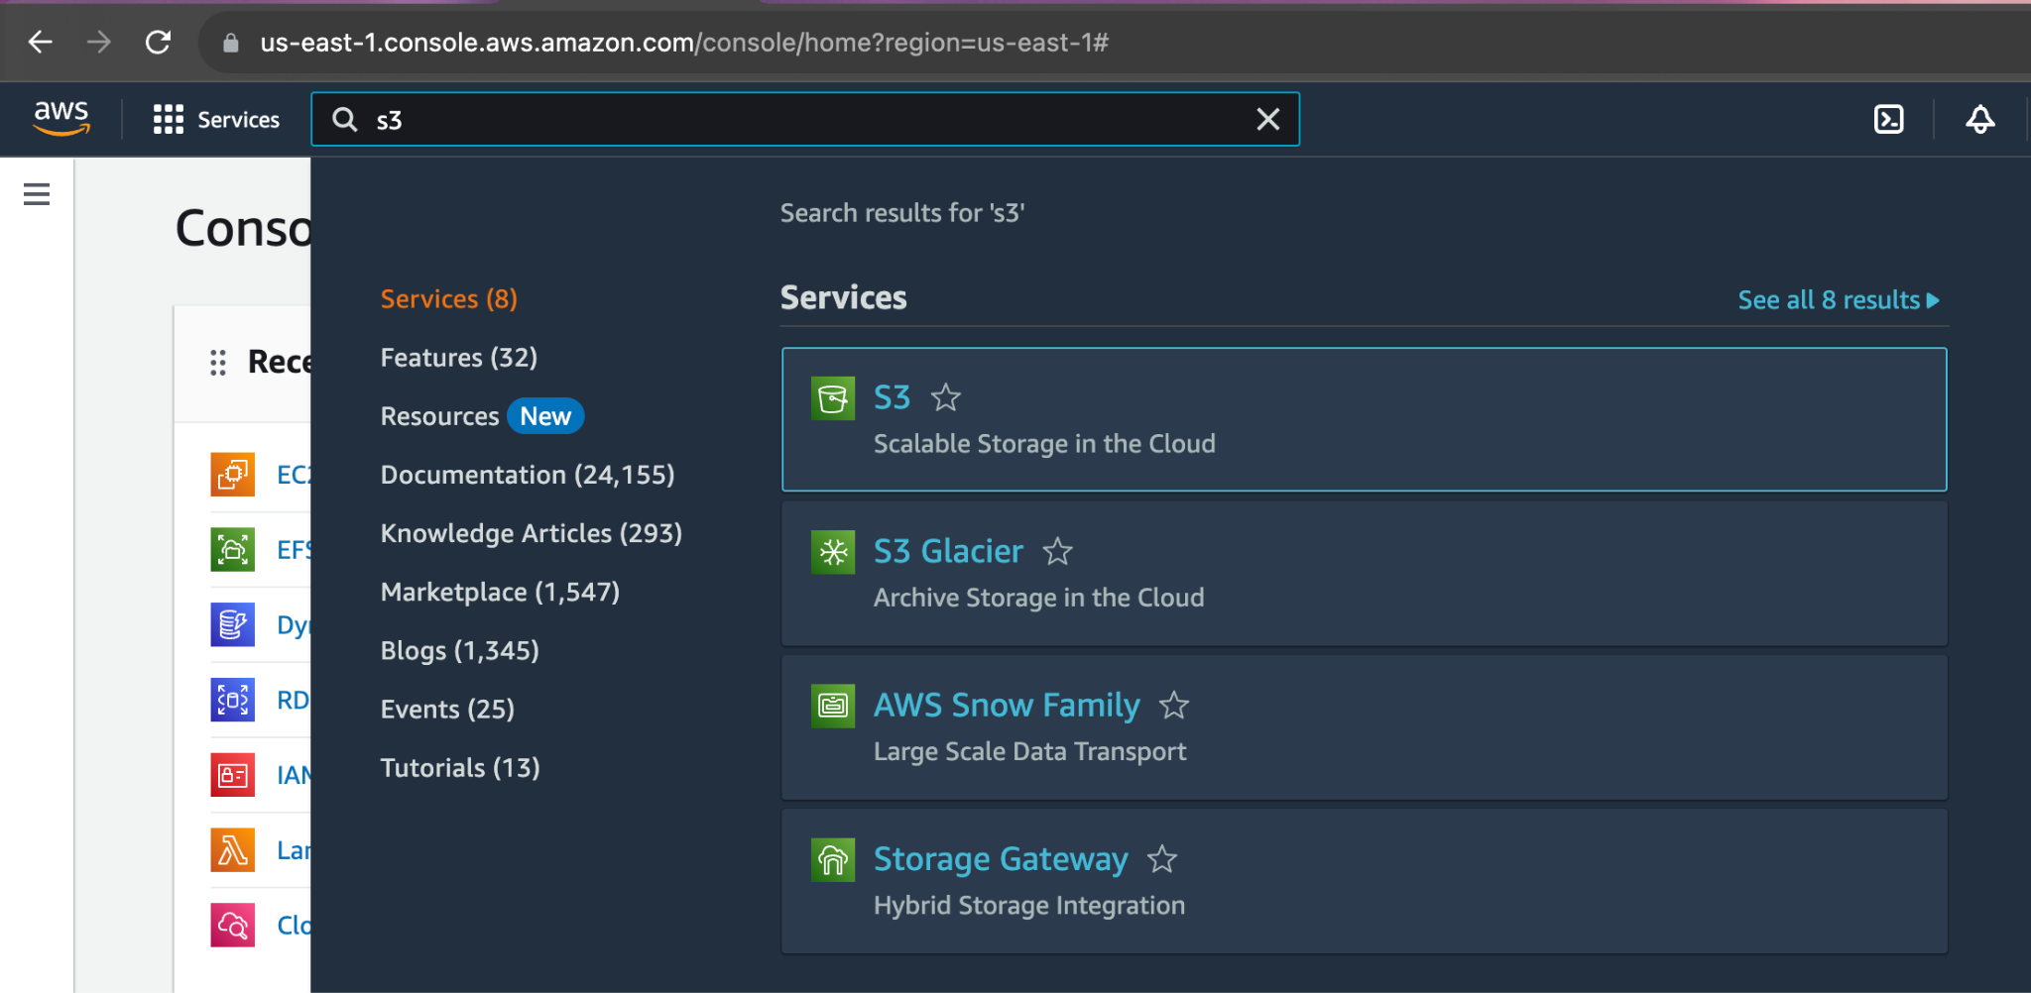

## **Step 3.** This Screen will appear. Now click on create bucket to create a S3 bucket.

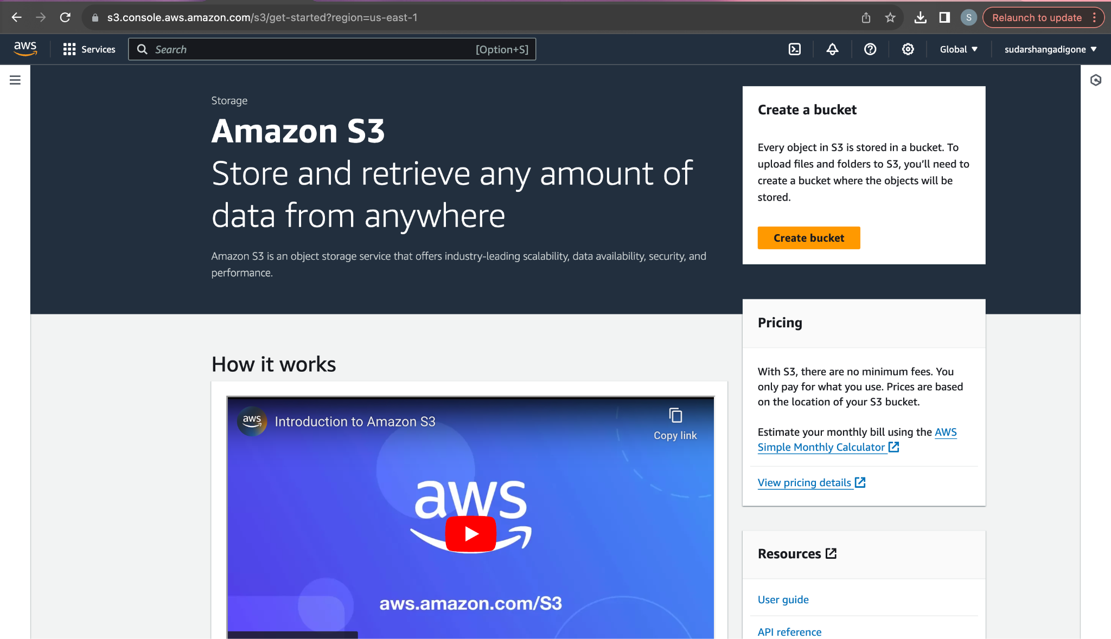

## 

## 

## 

## 

## 

## 

## 

## 

## 

## 

## 

## 

## **Step 4.** Enter a unique bucket name in the bucket name box.

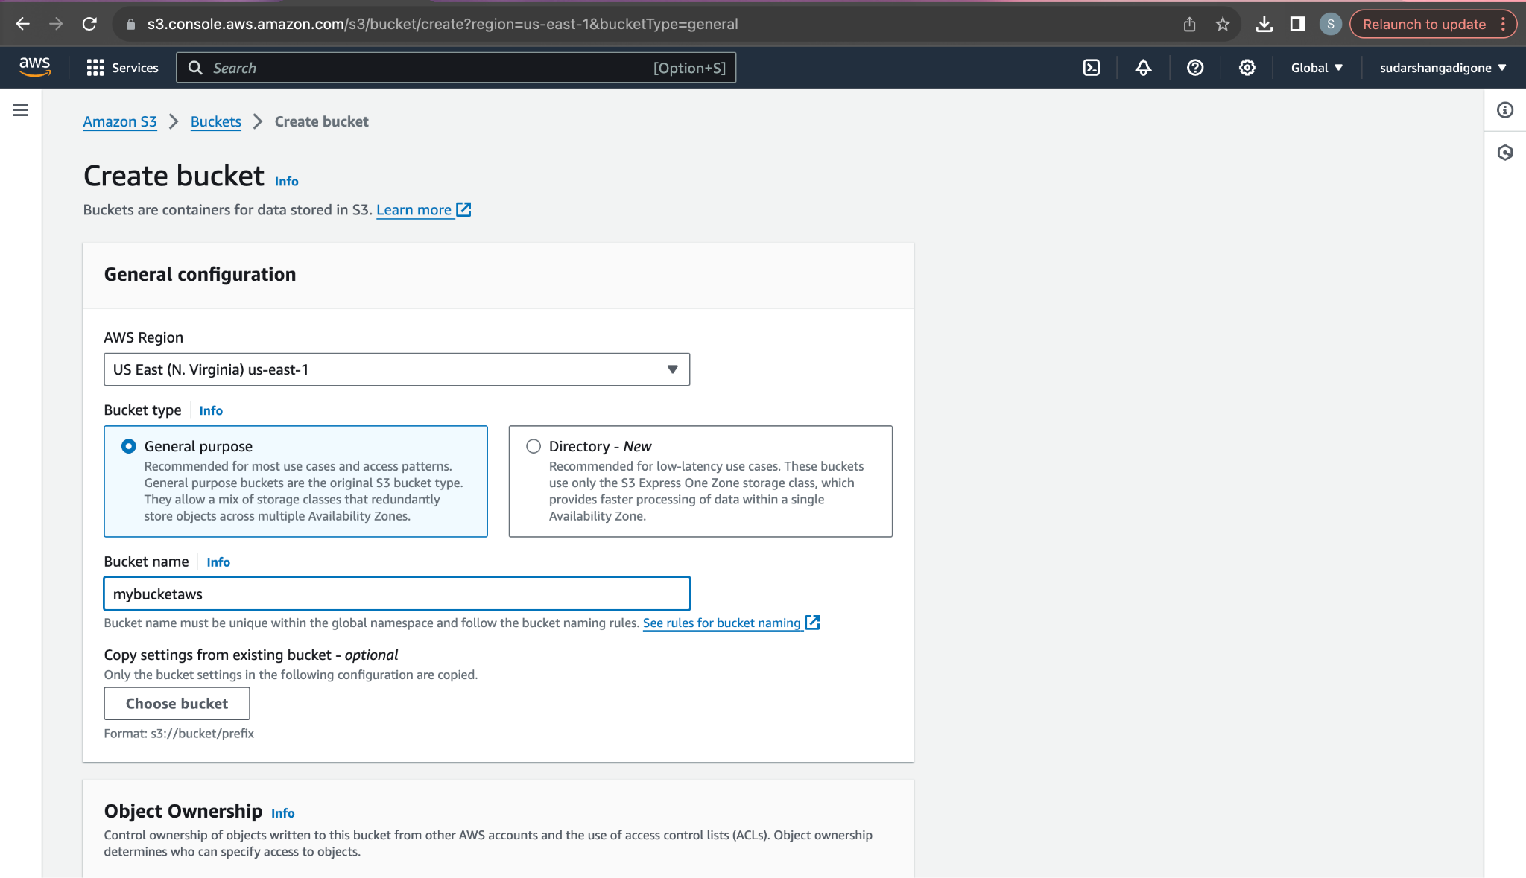

You can also add tags to the bucket which is optional.

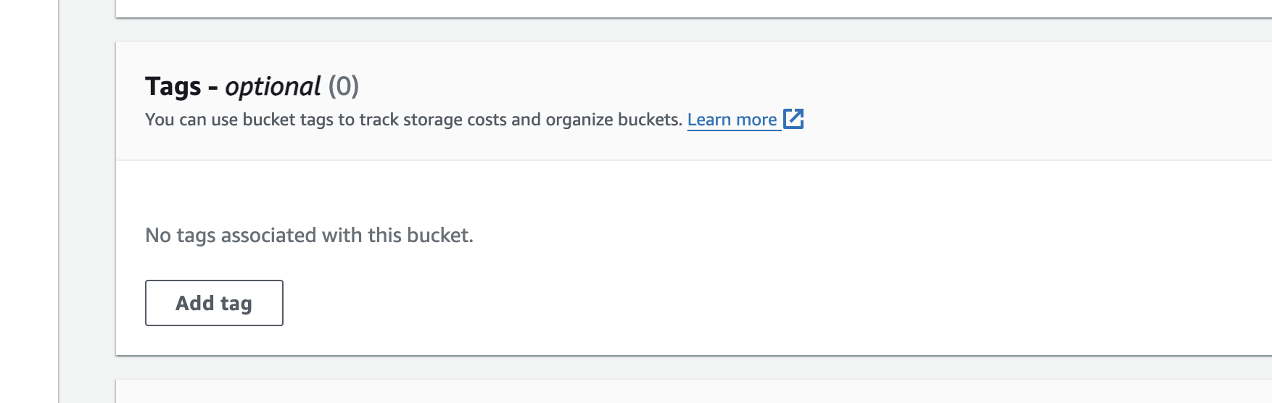

## **Step 5.** Click On create bucket option. Hence we have successfully created a bucket.

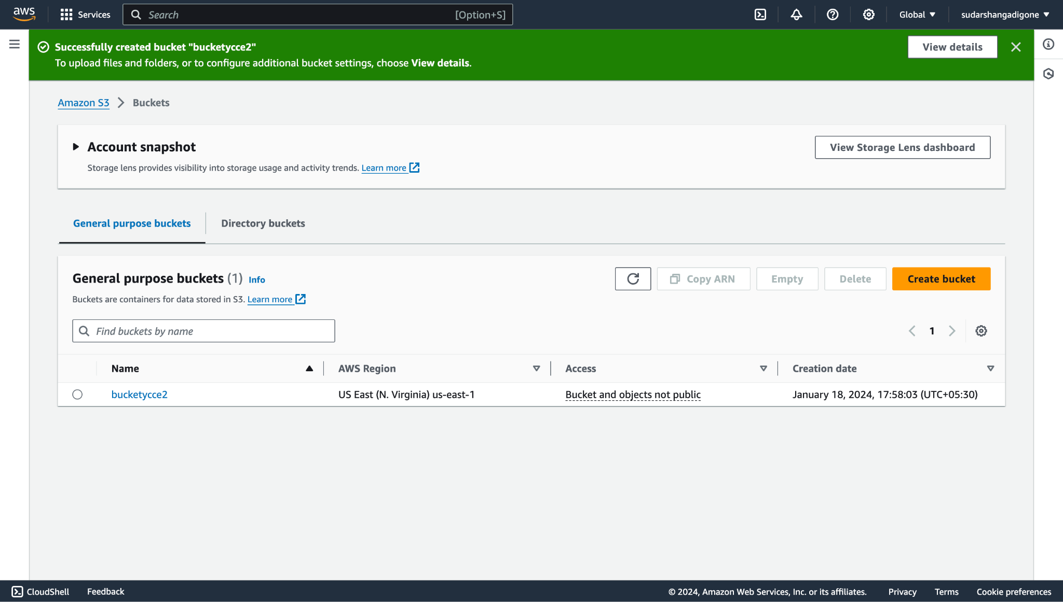

## **Step 6.** Now Navigate to the EC2 console.

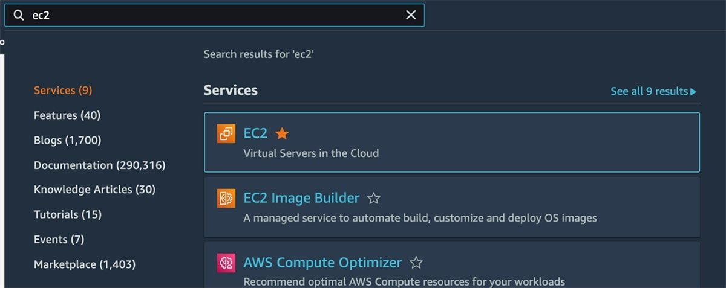

## **Step 7.** Search for **EBS**(Elastic Block Store) on the left hand side panel. Under it search for Volumes.

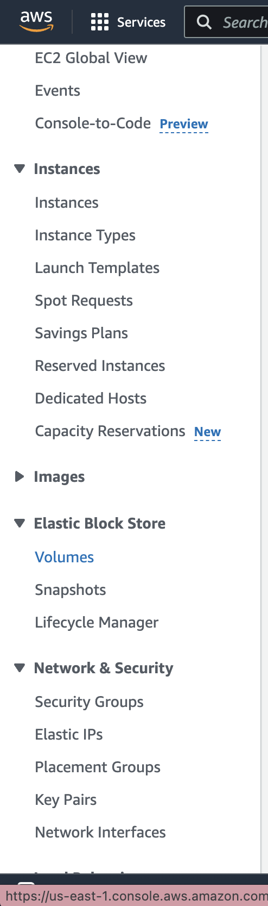

## **Step 8.** Click on create volume and create a volume as per user’s or organization’s choice.

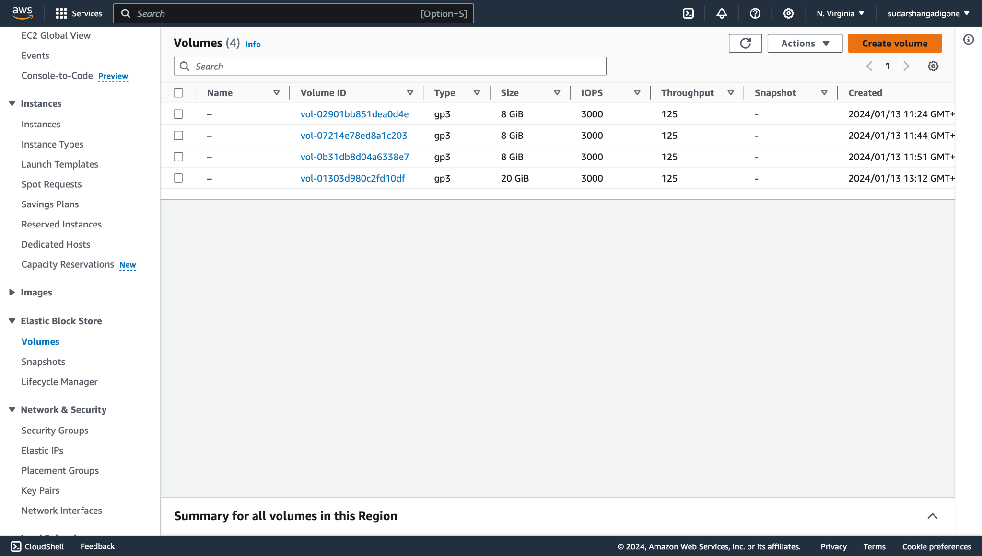

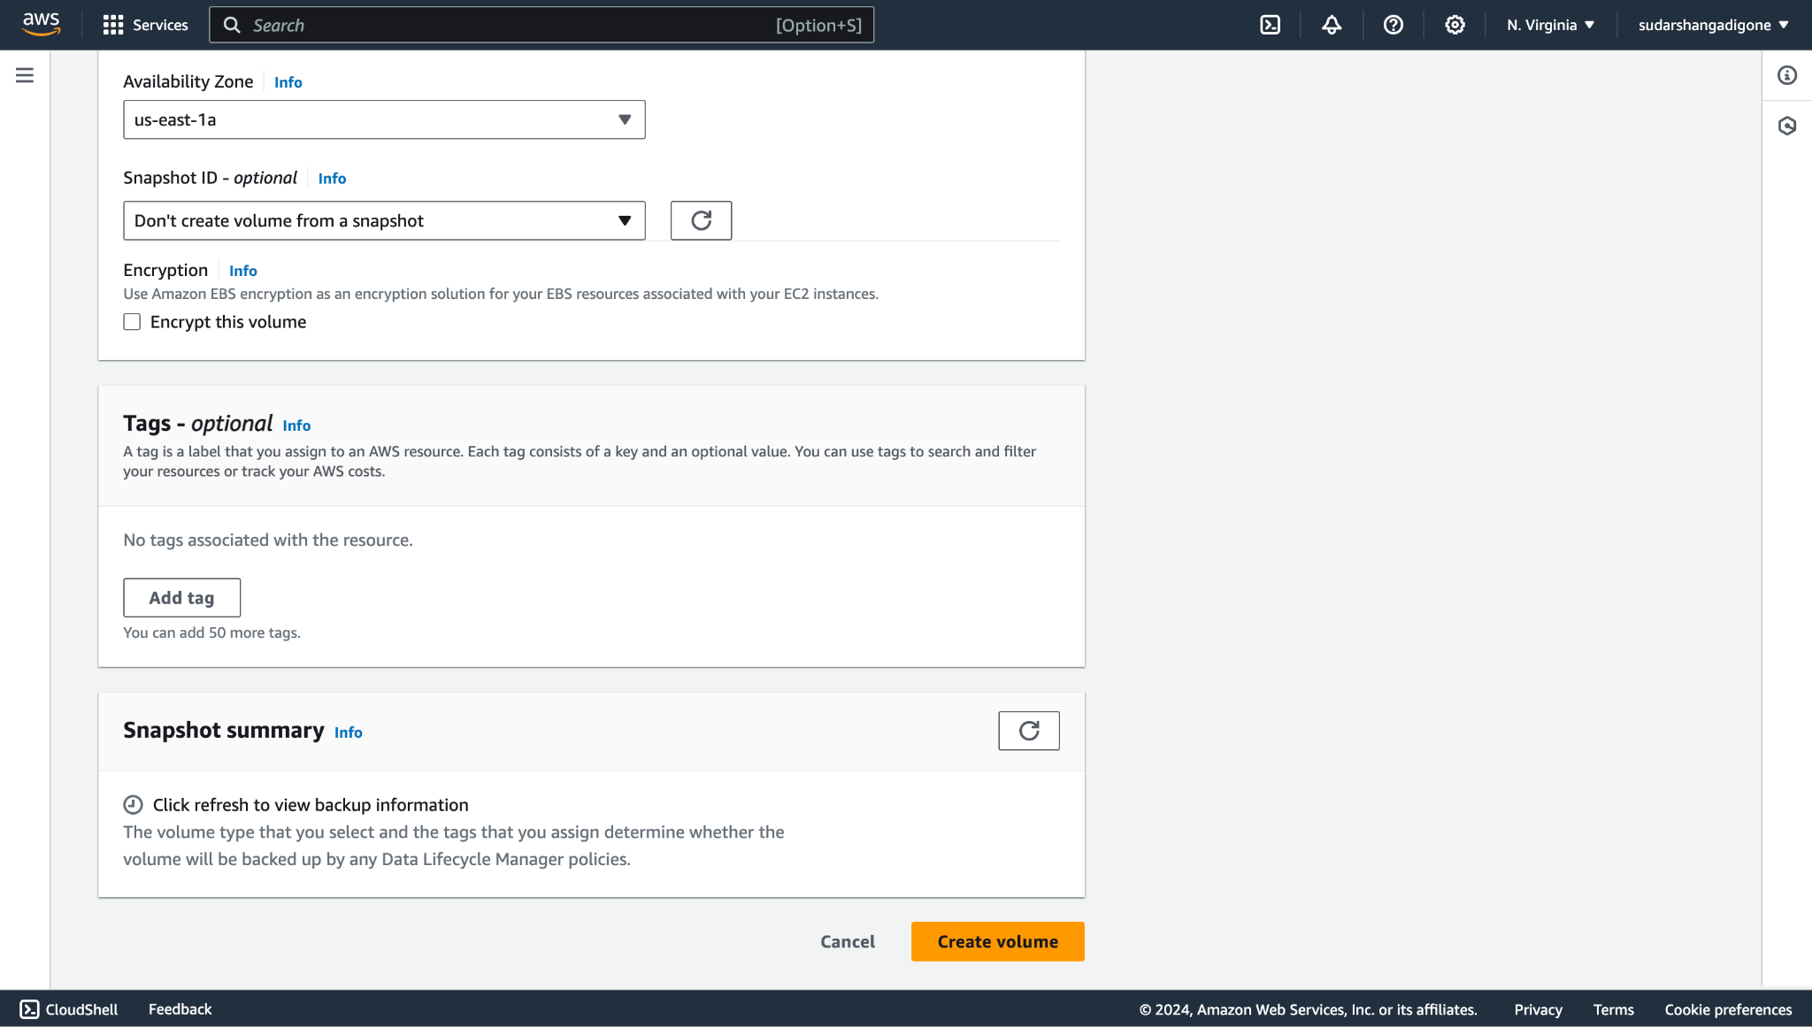

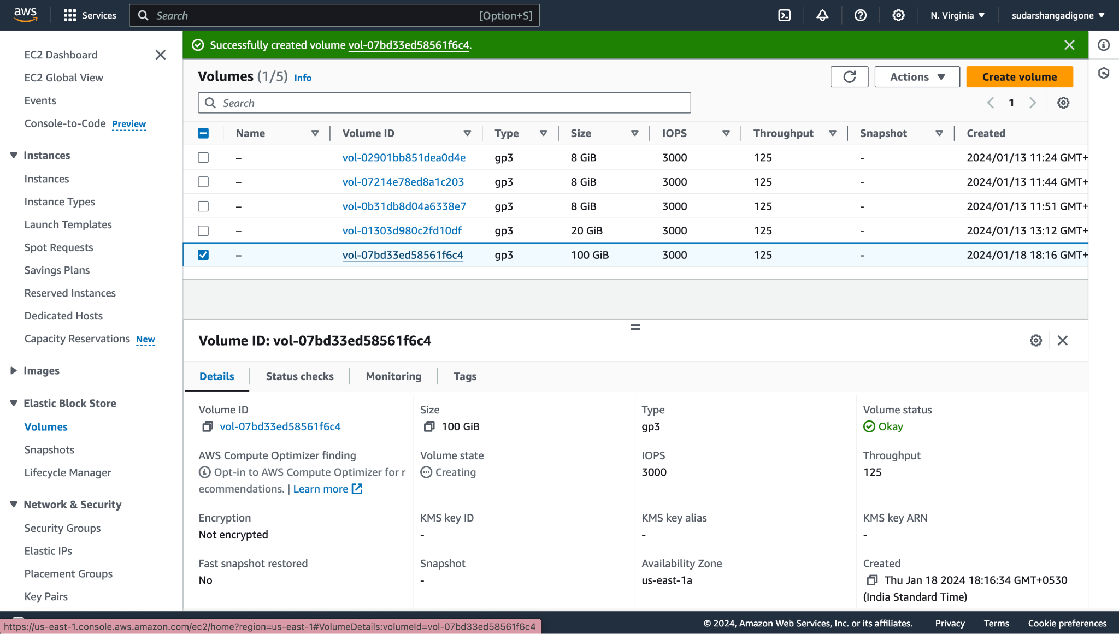

The volume has been successfully created.

**Step 9.** Go to Amazon EFS Console.Click the "Create file system" button

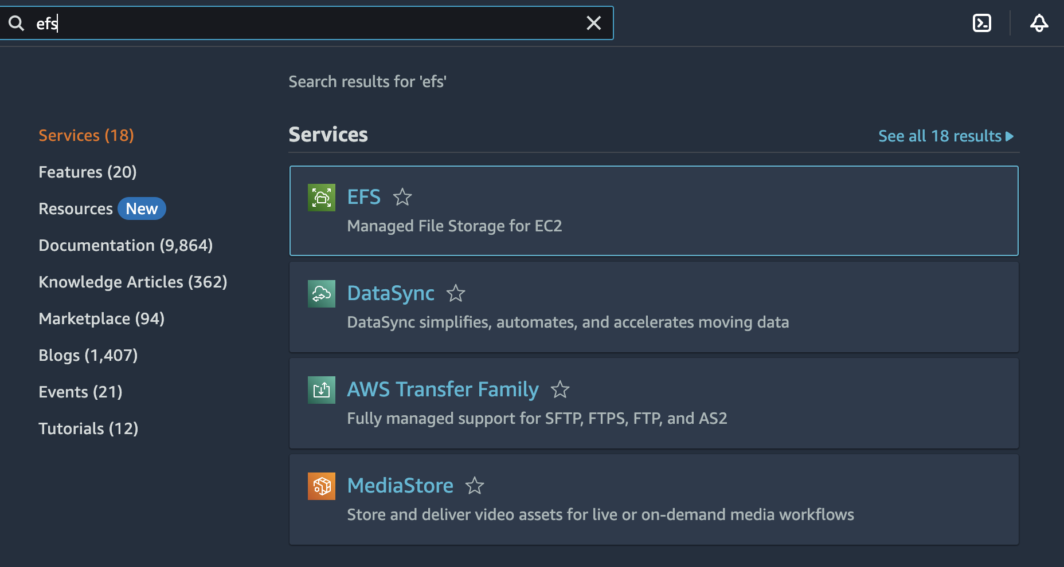

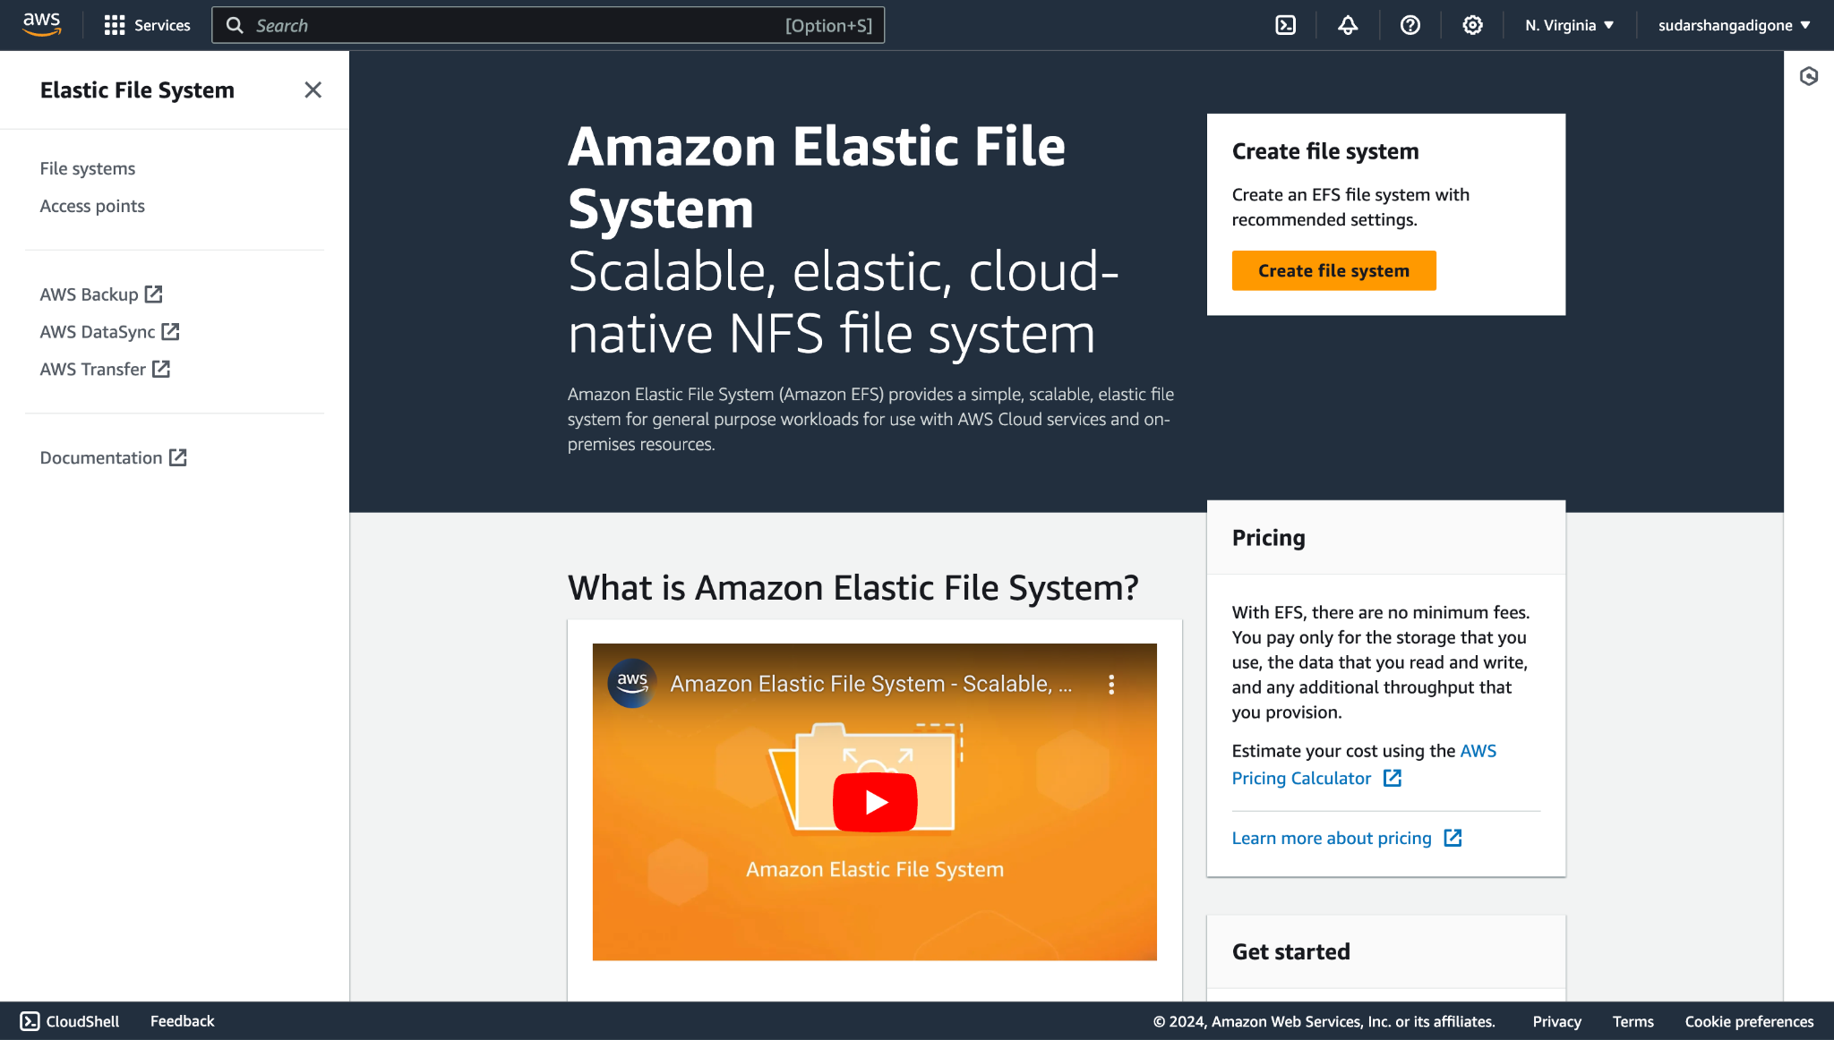

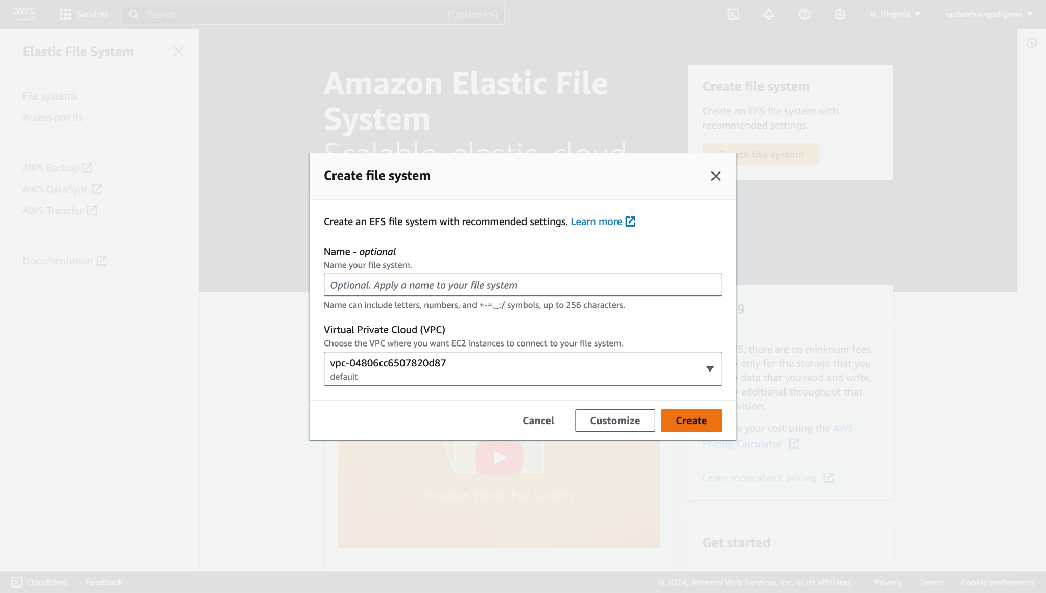

Thus, we have created a CFS and can now add data into it.

**CONCLUSION:**

Thus we have successfully created S3 Bucket , EBS and EFS.